Toy Model Hauxong

Toy model proposed by Hauxong to show bifurcation shift when added diffusion.

$$\frac{dΦ}{dt}=βΦ-ωΨ+f\left(t\right) \frac{dΨ}{dt}=ωΦ+βΨ +f(t)$$

Where

$$f\left(t\right)=\left(bΨ-Φ\right)\left(Φ^{2}+Ψ^{2}\right)$$

Jacobian evaluated at stable point.

$${J|}_{(0,0)} =\left[\begin{matrix}β & -ω \\ ω & β\end{matrix}\right]$$

$${\left(λ-β\right)}^{2}= -ω^{2}$$

$$λ=β±ωi$$

# Example 1

w = -1/1.5;

b = 0.01;

## Short Time Frame

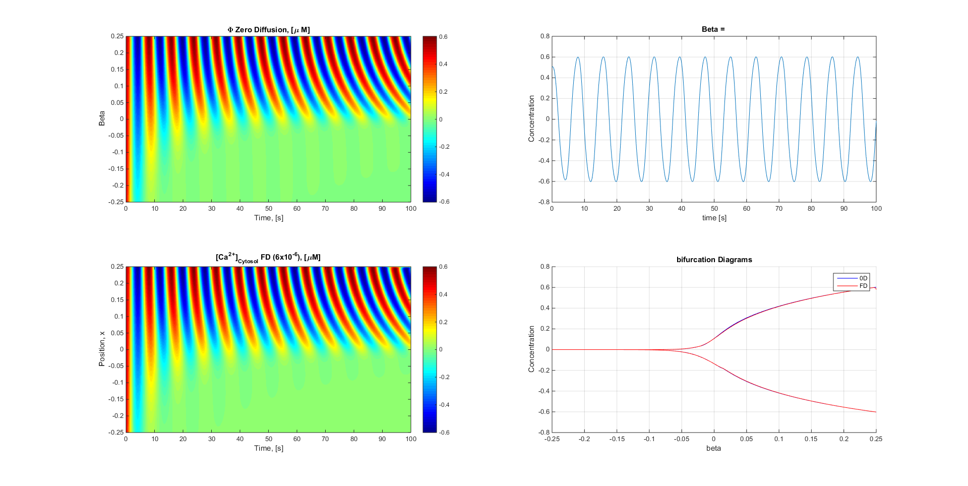

## Long Time Frame

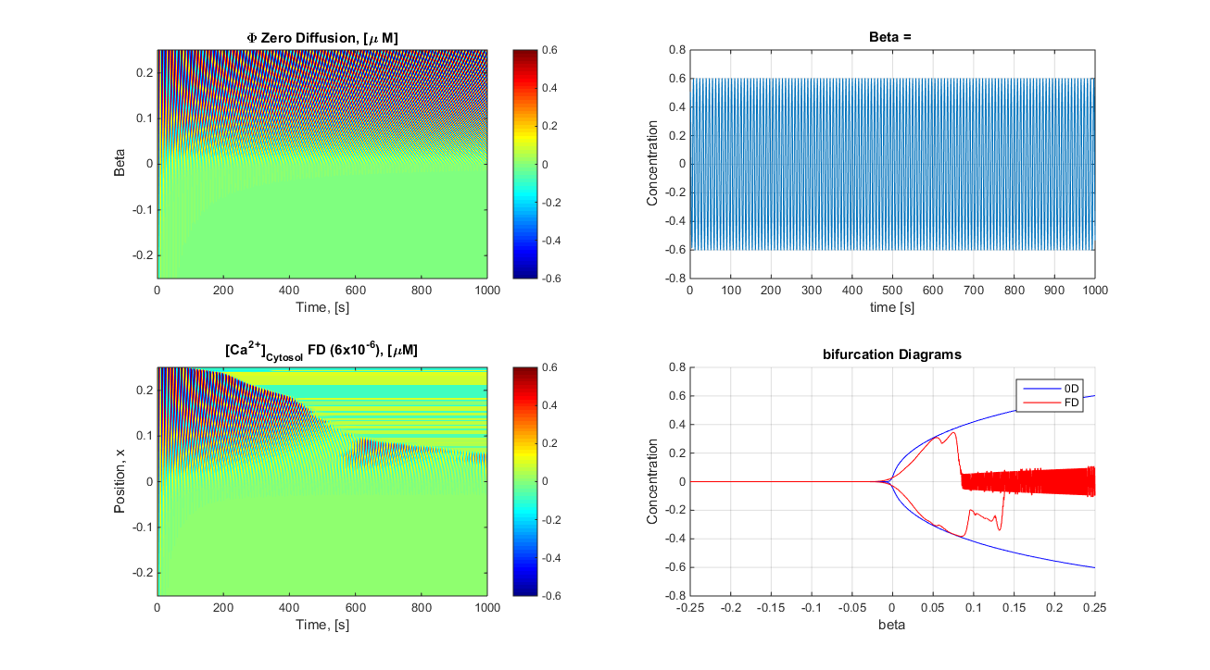

$ω$ and *b* determines stability (attracting fixed point osculations compared to repelling). When it is less than zero unstable oscillations. I don’t think the difference in the bifurcation is enough to justify the findings.

Epslon/2*({0:0.25}^2- (-0.66)^2) at beta = 0 stability is epslon/18

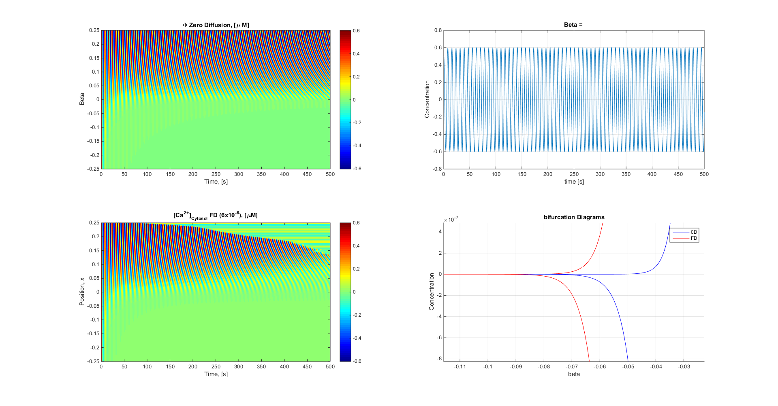

# Sign / constant change

$$\frac{dΦ}{dt}=βΦ-ωΨ+f\left(t\right) \frac{dΨ}{dt}=-βΦ+ωΨ +f(t)$$

Where

$$f\left(t\right)=\left(bΨ-Φ\right)\left(Φ^{2}+Ψ^{2}\right)$$

Jacobian evaluated at stable point.

$${J|}_{(0,0)} =\left[\begin{matrix}β & -ω \\ -β & ω\end{matrix}\right]$$

$$\left(λ-β\right)\left(λ-ω\right)-ωβ= 0$$

$$λ^{2}-\left(β+ω\right)λ=0$$

$$λ=0, β+ω∴when β>ω the solution is osculatory$$

# Example 1

w = 0.5;

b = 0.1;

### Short Time Frame

### 

### Long Time Frame

